Assignment 2: Dashboard

Team members: Polina Spasskaya MIM251

1. Business description

Business requirement for the dashboard
The dashboard is designed as a management tool that supports data-driven decision-making by transforming raw operational data into actionable insights. It provides a clear overview of lead conversion and revenue performance across customer segments.
Business context:
Xsolla is the B2B platform, which attracts video game developers (indie, mid-tier, enterprise) and generates revenue from their transactions.

Segments:
- indie — small developers with very limited budgets
- mid-tier — medium studios with stable income
- enterprise — large companies with big budgets.

Description of the business problem(s):
Xsolla attracts many leads, but it is not clear how they move through the pipeline and how many of them become paying partners. It is also unclear which customer segments bring the most revenue and how revenue changes over time.

Dashboard goals:
- Understand how leads convert into paying partners
- Track revenue over time
- See which segments bring the most revenue
- Help decide which segment to focus on

Key questions that the dashboard should answer:
- What is the estimated conversion between pipeline stages?
- How does revenue change over time?
- Which lead segments generate the highest revenue?
- Which segment should the company focus on to increase revenue?
Target audience:
- Senior managers responsible for business growth
- Business development and sales teams

2. Data preparation

Data
The dataset consists of two related data sources:
Company pipeline data: Company ID, Name, Segment, Region, Stage
- Segment: indie, mid-tier, enterprise
- Stage: Lead, Negotiation, Partner
- Region: North America, Europe, LATAM, MENA, APAC
Revenue data: Company ID, Month, Year, Revenue
Data tables and the prompt for data generation are provided in the Yandex disk.

Data descriptive statistics
The company pipeline dataset contains 420 companies with one record per company.
There are no missing values or duplicates, and all categories are consistent.
The distribution of companies shows:
- most companies are indie (55%),
- mid-tier represents 31%,
- enterprise is the smallest group (14%).
By stage:
- about 50% are leads,
- 25% are in negotiation,
- 25% are partners.
This indicates a typical B2B pipeline structure, where only a part of leads convert into paying partners.
It is important to note that the pipeline data represents a snapshot of the current state rather than a historical funnel. Each company belongs to only one stage at a given time, and transitions between stages are not tracked. Therefore, the funnel reflects the distribution of companies across stages, not actual progression over time. Conversion rates derived from this data are approximate and should be interpreted as stage ratios rather than true conversion metrics.
The revenue dataset contains 30,240 records covering the period 2020–2025.
Each company has full monthly data (72 months), with no missing values or duplicates.
Main statistics:
- average revenue: 8,382
- median: 0
- max: 2.58M
The distribution is highly skewed, with many zero values and a small number of large transactions.
A large share of revenue values is equal to zero. This is not a data quality issue, but a result of the business logic: only companies at the “Partner” stage generate revenue, while Lead and Negotiation stages have no transactions. Therefore, zero values were preserved, as they correctly reflect inactive or non-converted companies and are essential for time-series and funnel analysis.
Revenue generally grows over time: from $29M $ in 2020 to a peak of ~$54M in 2024, with a slight stabilization in 2025.
Revenue by segment of total revenue:
- enterprise ~95%
- mid-tier ~5%
- indie <1%
At the same time, mid-tier shows the most stable revenue, while enterprise is more volatile.

Data cleaning and transformations performed
The data was checked for:
- missing values,
- duplicates,
- incorrect categories,
- invalid dates and revenue values.
No issues were found, so no cleaning was required.
However, special attention was paid to zero revenue values, which were validated as consistent with the business logic rather than treated as missing or erroneous data.
The datasets were joined using Company ID to enable combined analysis of pipeline and revenue.
Revenue was aggregated by: month, year, segment.
This allows the dashboard to analyze:
- conversion through the pipeline,
- revenue trends over time,
- differences between customer segments.

3. Dashboard design

Dashboard concept:
The dashboard follows BI best practices by combining KPIs, trend analysis, and segmentation to provide a clear and actionable overview of business performance.

Dashboard model:
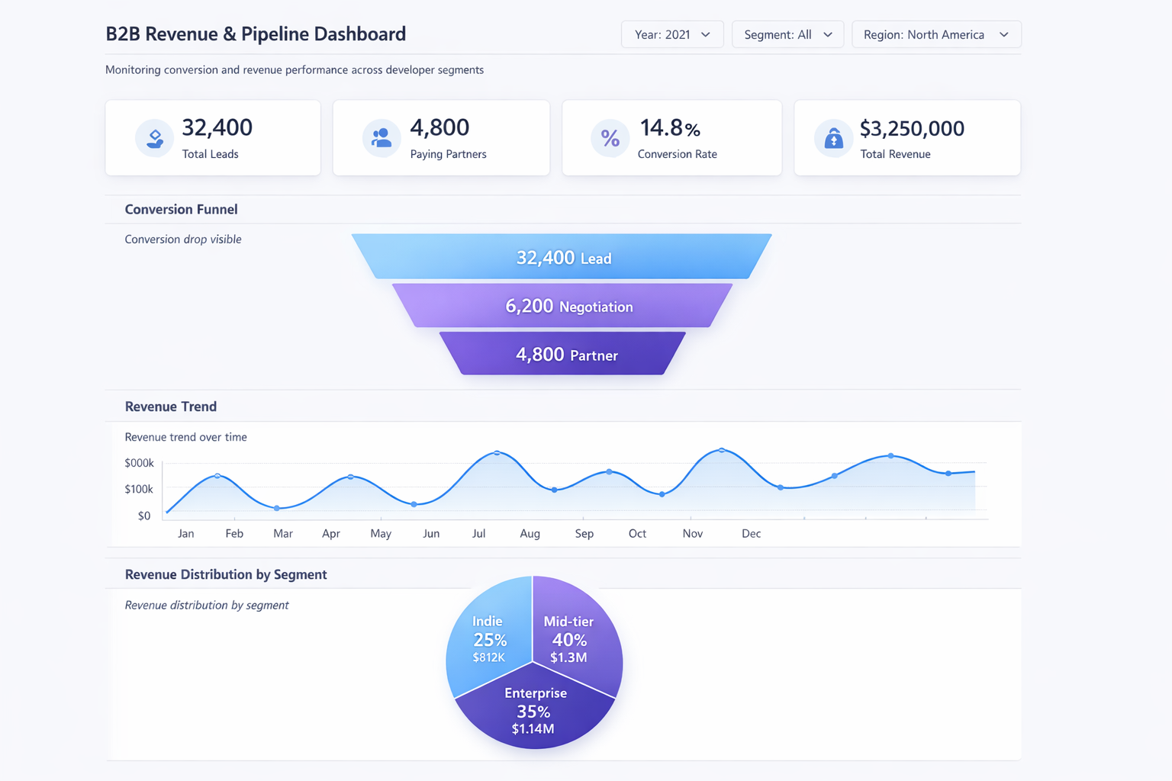

Dashboard structure:
KPI cards (top section):
- Total Companies — total number of companies in the pipeline
- Paying Partners — number of companies at the “Partner” stage
- Total Revenue — total revenue generated by partner companies
Pipeline Stage Distribution (bar chart):
Displays the distribution of companies across pipeline stages (Lead, Negotiation, Partner).
This visualization represents a snapshot of the current pipeline structure, rather than a historical conversion funnel.
Line chart (Revenue trend over time):
Shows how revenue evolves over time, allowing identification of growth patterns, volatility, and seasonal effects.
Pie chart (Revenue distribution by segment):
Displays the contribution of each segment (indie, mid-tier, enterprise) to total revenue, highlighting revenue concentration.
Table (Revenue by region and segment):
Provides a detailed breakdown of revenue across regions and segments, supporting identification of regional performance gaps and growth opportunities.
Filters:
- Year, Month
- Region
- Company segment

4. Created dashboard

Link to the dashboard
https://visiology.hse.ru/v3/dashboard-viewer?workspaceId=e3abf30a-da3f-457e-b43e-98b697ed5fff&dashboardGuid=1f89965c0b134e16a12ce77faaea35a3&showNav=true

Dashboard screenshot
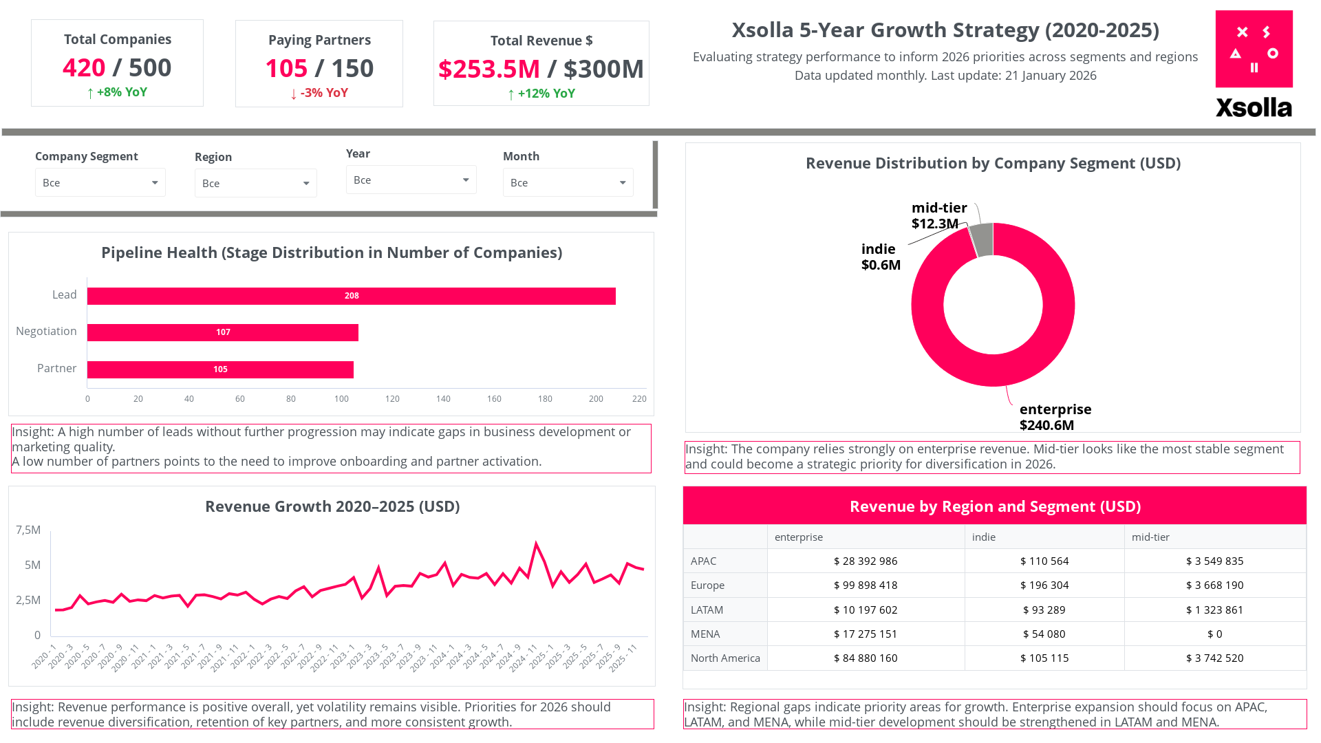

5. Dashboard Alarms
The dashboard includes several decision-support triggers aligned with the key business questions:
- If the share of companies at early stages (Lead, Negotiation) is significantly higher than at the Partner stage → this indicates an unbalanced pipeline structure and limited monetization potential
- If the share of Partner-stage companies is low relative to total companies → this suggests that only a small portion of the pipeline contributes to revenue
- If revenue shows a declining or unstable trend over time → this may indicate issues with partner activity, retention, or external market conditions
- If revenue is highly concentrated in one segment or region → this indicates dependency risk and the need to diversify revenue sources
- If certain segments or regions have low representation at the Partner stage or generate minimal revenue → these groups may require revised targeting or engagement strategies
6. Review of another dashboard

Reviewer: Polina Spasskaya
Dashboard being reviewed: Dashboard being reviewed: Effectiveness of AI support agent
Dashboard being reviewed created by: Team members: Sofiya Karpova, Egor Konstantinov, Andrei Velicorodno

1. Summary & First Impression
The dashboard is designed to evaluate the impact of an AI support agent on customer service performance and operational efficiency. The overall purpose is clear, and the structure is logical and easy to follow.
The first impression is very positive: the dashboard looks clean, well-organized, and covers all key aspects of support performance. At the same time, it includes quite a lot of information on one screen, which may take a moment to fully explore.
2. What Works Well
A strong point of the dashboard is its clear business focus. It answers a specific and relevant question about AI impact rather than presenting isolated metrics.
The before/after comparison is especially effective, as it allows the user to quickly understand how key indicators have changed after AI implementation.
It is also great that the dashboard combines quality, speed, and efficiency metrics — this makes it very useful from a management perspective.
3. What Could Be Improved
Some sections, particularly the Top KPI block, contain many indicators, so a bit more visual grouping or labeling could make them even easier to read.
There are also interesting insights, such as differences in reopen rates between AI and human-resolved chats, that could be highlighted slightly more to draw attention.
The topic chart adds helpful context, and a small clarification of its role in the overall analysis could make it even more intuitive.
Finally, adding a short summary or key takeaway section could help users quickly grasp the main conclusions.
Overall
Overall, this is a strong and well-thought-out dashboard that addresses an important business problem. With a few small adjustments, it could become even more intuitive and impactful for decision-making.

